Note: Include this page only when adding / amending / deleting a document. If using this document as a record, this Revision History page can be omitted.

REVISION HISTORY
Revision no | Date | Description of Changes | Reason for Revision | Revised by | Approved by:
3 | 15 Mar 13 | Add revision history page  Include email approval of the DRC  Revise process of document approval | Recommendation from Stage 2 audit  CPIAR #230 & #232 | CMRojas  RDPlacido
4 | 21 June  13 | Include ISO docs quarterly back up | CPIAR#222 & 331 | RDPlacido
5 | 25 July  14 | Revise authorized signatories | Consistency | RDPlacido
6 | 08 Sep 14 | Delete Account Management and Change Sales to Sales and Account Management | Merging of Sales and Account Management Process | ANOngkeko
7 | 14 July 2015 | -Revised authorized signatories.  - Eliminated the maintenance of hard copies by using the CPI ISO Google site as the main repository of our QMS documents.  -Added note regarding inclusion of “Uncontrolled when printed.”  -Changed file name of the uploaded file. | It was identified that Execom does not need to approve all types of documents.  To reduce resources in maintaining the QMS documents.  For easy identification of version document. | RCGanal | ECVentura  RMGruet
8 | 11 Dec 2015 | Added the Unit Heads and the QMR in the responsible parties.  Changed the process for Document Request for Change (DRC) from manual to automated using the Online DRC filing system.  Added ED for Externally Generated Documents in the list of document types section  Added GD and GS in the units, GW,GC and GH in the sections.  Changed Special Projects to Projects | Process for Document control was changed due to automation of the process.  New Sections and Units were added due to reorganization. | RCGanal | ECVentura RMGruet

- Objective
To ensure the proper handling and safekeeping, timely distribution and correct disposal of all documents related to the quality management system of the company.

- Scope
This procedure defines the action and responsibilities of the Document Control Staff, Unit Heads and the QMR in the proper handling of the company’s documents related to quality management. This includes activities that start from the document control staff receiving the documents until such time when obsolete documents are disposed of.

- Definition of Terms
QMR | Quality Management Representative
DC | Document Controller
EGD | Externally Generated Documents

- Procedure Details
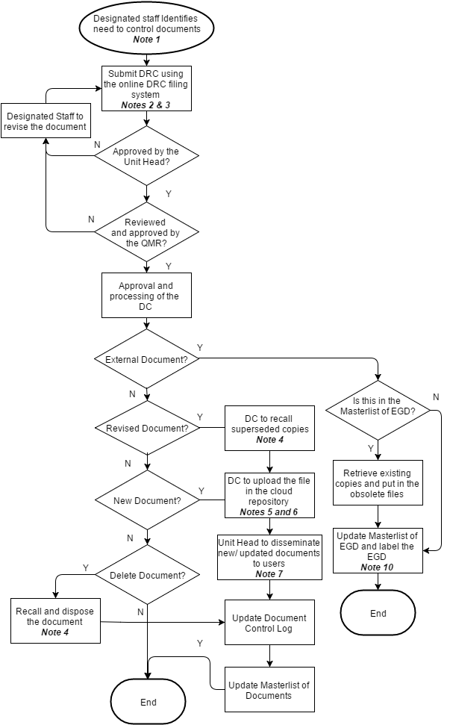
Notes:
- The Document Controller must perform a quarterly back up of all ISO documents on the Google site every last week of March, June, September, and December. The documents will be saved at the \\server-06\isobk$ local repository.

- The designated staff logs on to the Online DRC Filing system. The URL is http://192.10.10.32/login. For new documents, secure a document code from the DC. For document revisions triggered by improvements, client feedbacks, or IQA findings, please indicate the NC/CPIAR IDs. Unit head and QMR review and approval will be captured in the system.
- Assign code to the documents based on the established document coding scheme DD-SS-UU-nn where

DD – document type, namely:
QM | Quality manual
QS | QMS Plan
SQ | SQC Plan
PM | Procedures Manual
ML | Master List of Quality Records
WI | Work instructions
JD | Job description
FO | Form
ST | Standard
CL | Checklist
GD | Guideline
TM | Template
ED | Externally Generated Documents

SS-section code

 | Section Code
 | IN | Control of Quality Manual
1 | QI | Quality System Introduction
2 | CS | Company Statements
3 | OS | Organizational Structure
4 | BU | Business Process
5 | BP | Business Planning
6 | BD | Marketing and Business Development
7 | SL | Sales and Account Management
9 | SI | Geniisys System Implementation
10 | SM | System Maintenance
11 | SP | Projects
12 | TR | Customer Training
13 | SA | Staff Augmentation Services
14 | HR | HR Services
15 | AD | Admin Services
16 | FI | Finance Services
17 | IT | IT Infrastructure Services
18 | EC | Employee Competence Development
19 | BR | Business Review and Improvement
20 | GW | Geniisys Web Development
21 | GC | Geniisys CS Development
22 | GH | Geniisys Hybrid Development

UU – unit which owns the process
HR | Human resources and admin
IT | Information technology
SD | Service delivery
BD | Business development
FI | Finance
MG | Management
AD | Administrative Services
GS | Geniisys Services
GD | Geniisys Product Development

nn – series
00-99 document number. Each section should maintain a number series for
each type of document.

- Retrieve outdated or deleted copies of documents from Google Sites and move to a bucket of obsolete files in Amazon Web Services S3 cloud and its file name revised in the following format:

O Document code Effectivity date Description
Where O = indicates obsolete copy

- The approved document will be uploaded in the CPI ISO Google Sites and will be available to all personnel subscribed to it. Hard copies will not be maintained starting July 14, 2015.

The file name of the uploaded document shall follow the format:

Document code Effectivity Date Description

Where Document code = DD-SS-UU-nn
Effectivity date = yyyymmdd
Description = title of the document

For sorting purposes, QM, QS and SQ documents will be numbered in ascending order based on their sections.

- After uploading the file in the cloud repository, the DC shall notify the approving Unit Head through email.

- Unit head/s shall cascade the new document to all concerned parties. For supporting documents, email notification is enough. For Procedures, and other documents that need explanation, they shall submit the attendance of the cascading meeting.

- Unit Heads conduct a review of documents based on the Document Review Schedule set by the QMR. The purpose is to check if the current document reflects the current practice.

Type of Document | Frequency of Review
Quality Manual and annexes | Every 3 years
Procedures Manual | Every 2 years
Supporting Documents | Every year

The Unit Head/designated staff shall refer to the Document Re-Approval checklist when conducting the review.

- The authorized signatories for new or revised documents are as follows:

Type of Document | Prepared by | Reviewed by | Approved by
Quality Manual | Designated Staff | QMR | Execom
QMS / SQC | Designated Staff | QMR | Unit Head
Procedure Manual | Designated Staff | QMR | Unit Head
Supporting Documents | Designated Staff | QMR | Unit Head

- If available, the Revision Number and / or Effective Date shall be taken from the document originator’s
  - Copyright date
  - Version number
  - Issue number
  - Any other date or numbering system used by the originator

- All pages of the document should have “UNCONTROLLED WHEN PRINTED” (except for supporting documents that are filled up like checklists, forms and templates) to indicate that the printed document may be superseded. It is the responsibility of the personnel using the document to check whether he/she is using the latest revision.

- References
Document Re-Approval Guidelines
- Quality Records
- Document Archive (CPI ISO Google Sites, Amazon s3)
- Document Request for Control Form (Local Server)
- Masterlist of Documents
- Master list of Externally Generated Documents
- Document Re-Approval Checklist

